Cognizant Java FSE – (Deep Skilling)

(WEEK-3)

**MODULE 1:** Spring Core and Maven

**MODULE 2:** Spring Data JPA with Spring Boot, Hibernate

**Submitted by**  
**Name:** SOLLETI VENKATA KUSUMA  
**Roll No:** 111522102145  
**Email:** [22102145@rmd.ac.in](mailto:22102145@rmd.ac.in)

**College:** RMD ENGINEERING COLLEGE  
**Batch:** Java FSE – 2026

**MODULE 2:** Spring Data JPA with Spring Boot, Hibernate

**HandsOn-1:**Spring Data JPA - Quick Example

**SOLUTION:**

PROJECT STRUCTURE:

**SQL CODE:**

CREATE DATABASE ormlearn;

USE ormlearn;

CREATE TABLE country (

co_code VARCHAR(2) PRIMARY KEY,

co_name VARCHAR(50)

);

INSERT INTO country VALUES ('IN', 'India');

INSERT INTO country VALUES ('US', 'United States of America');

Country.java

CountryRepository.java

CountryService.java

OrmLearnApplication.java

Application.properties

pom.xml

OUTPUT:

**Hands On-4:**Difference between JPA, Hibernate and Spring Data JPA

**Java Persistence API (JPA)**

* JSR 338 Specification for persisting, reading and managing data from Java objects
* Does not contain concrete implementation of the specification
* Hibernate is one of the implementation of JPA

**Hibernate**

* ORM Tool that implements JPA

**Spring Data JPA**

* Does not have JPA implementation, but reduces boiler plate code
* This is another level of abstraction over JPA implementation provider like Hibernate Manages transactions

PROJECT STRUCTURE:

SQL CODE:

CREATE DATABASE hibernatedb;

USE hibernatedb;

CREATE TABLE EMPLOYEE (

ID INT PRIMARY KEY AUTO_INCREMENT,

FIRST_NAME VARCHAR(50),

LAST_NAME VARCHAR(50),

SALARY INT );

Employee.java

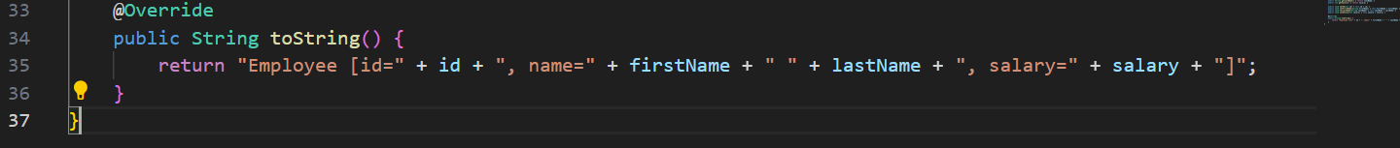

JPAMain.java

pom.xml

persistence.xml

OUTPUT:

